Sample templates
This layout is used in multiple areas of campus but the source content is swapped so it is local to that school/college/building.

Generic university template
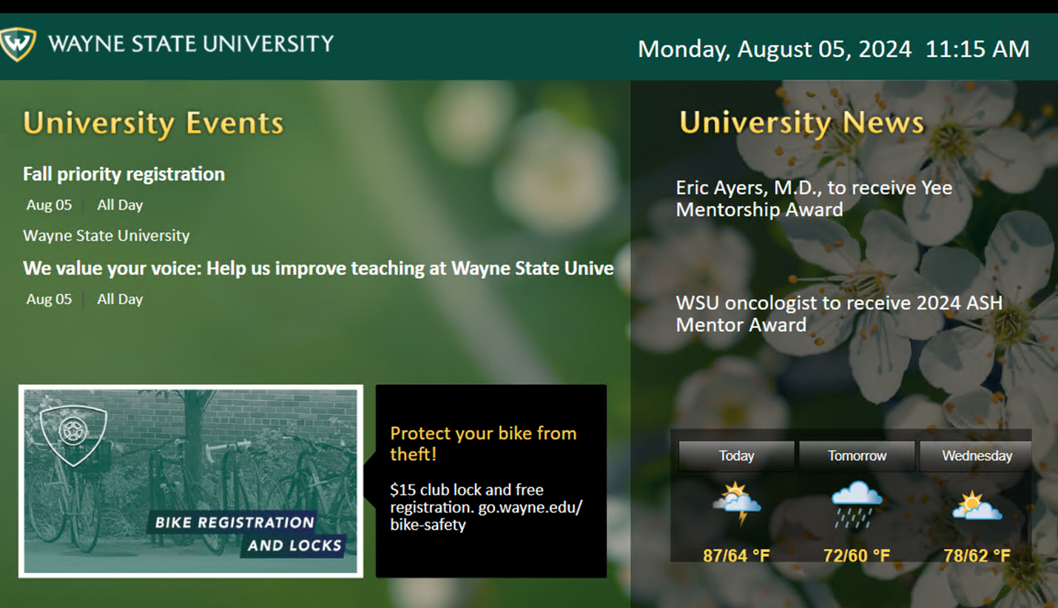

Each area pulls content from:

- https://events.wayne.edu/rss/calendar/main/index.xml
- https://signage.wayne.edu/feed/news/2001.xml
- https://signage.wayne.edu/promos/655/rss.xml
- (Weather widget built into templating software)

Full screen graphic
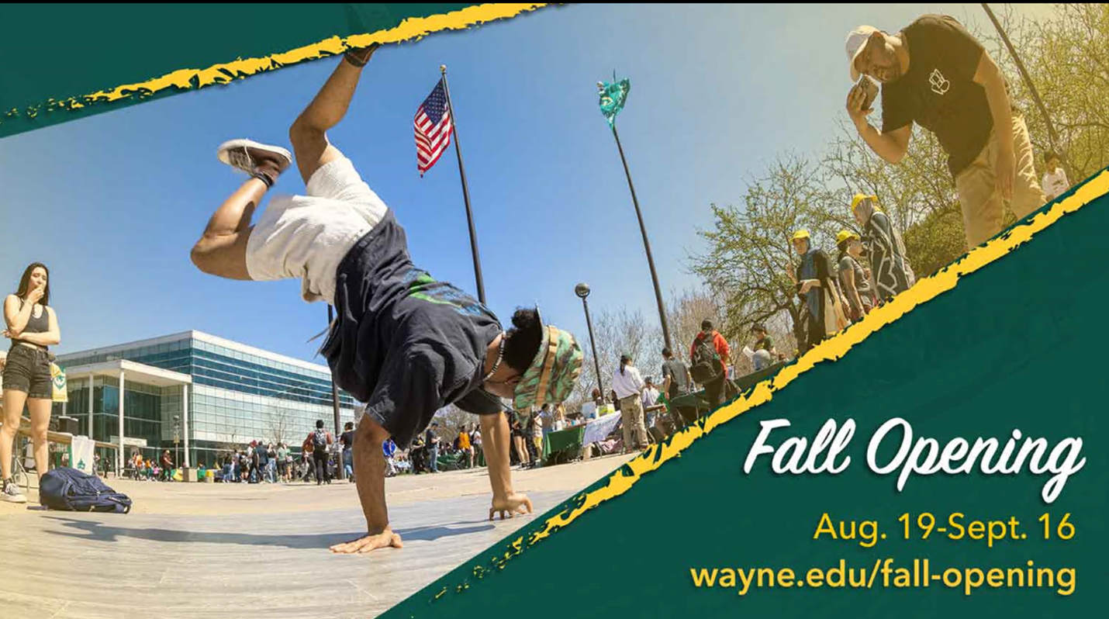

Rotates content from any active items in:
http://signage.wayne.edu/promos/1280/rss.xml
(If no active items, this template is skipped)

Example playlist of templates on a sign
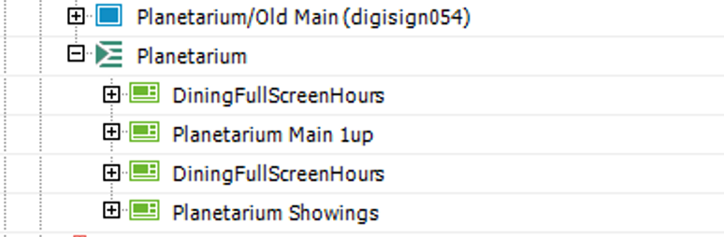

Example touch screen sign
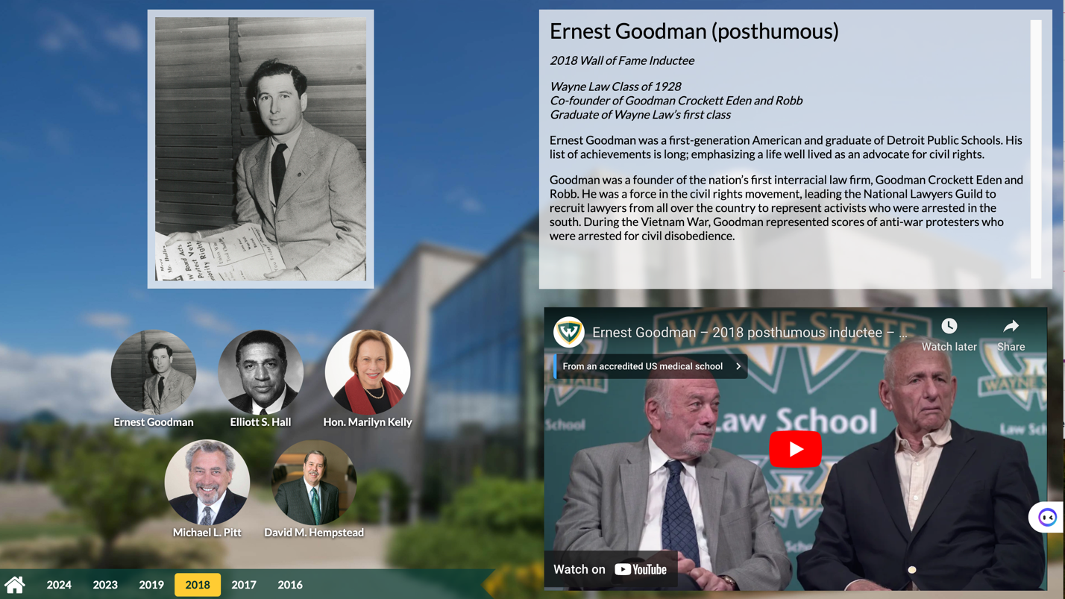

This is a web view of:
https://signage.wayne.edu/law-hall-of-fame

Example 4-screen display grid
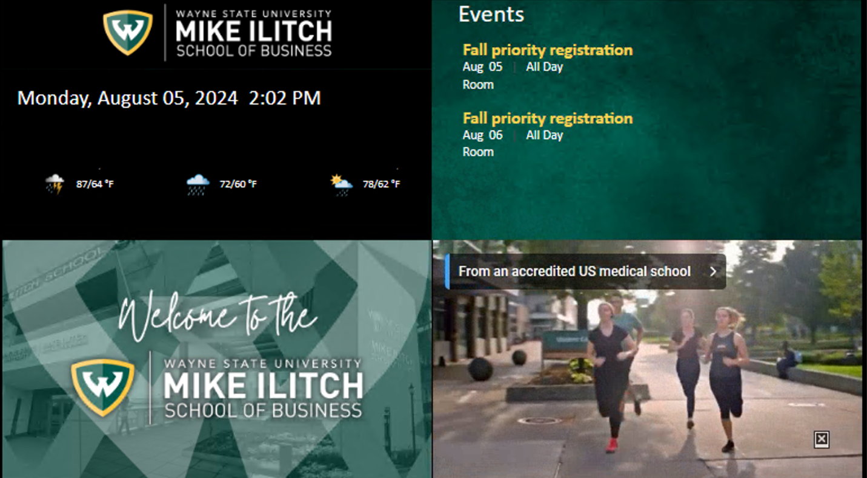

Content comes from:
- http://www.youtube.com/embed/eOMqOc5MrRg
- https://events.wayne.edu/rss/calendar/sba/
- http://signage.wayne.edu/promos/716/rss.xml
- Weather and time are signage software widgets

A webview of live data in our Welcome Center
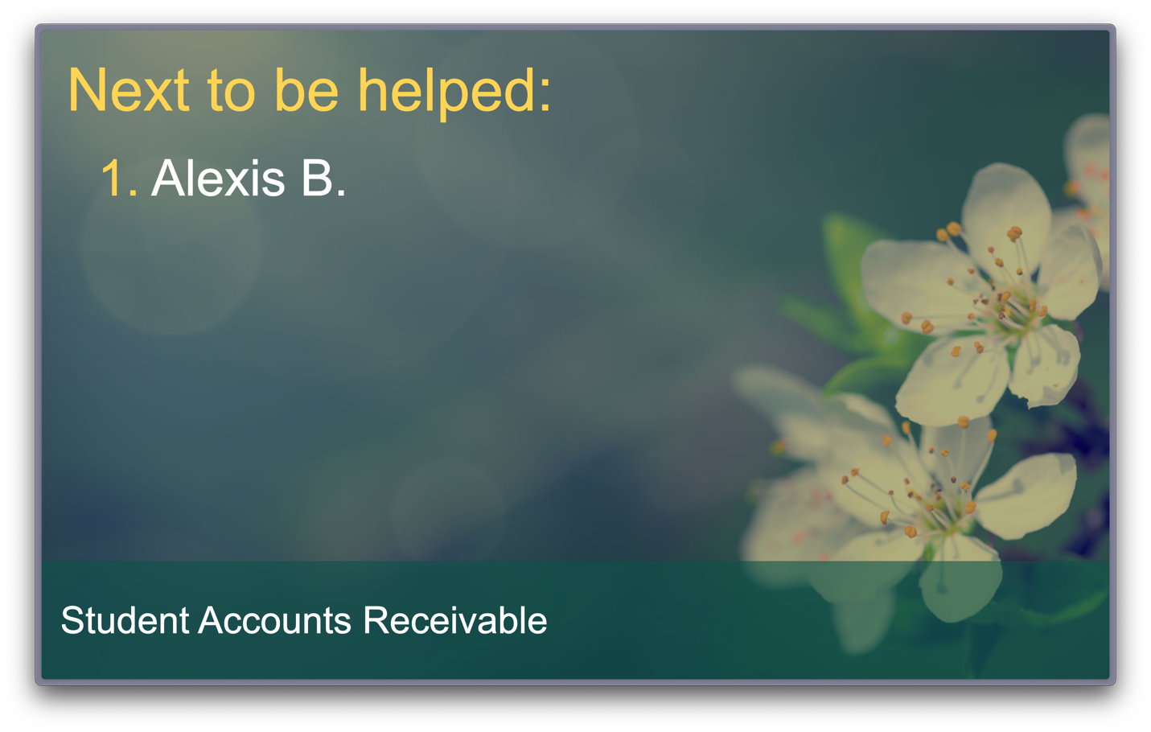

Sources:

- https://signage.wayne.edu/welcome-center/accounts-index.php
- https://signage.wayne.edu/welcome-center/

